RUNNING LIGHT

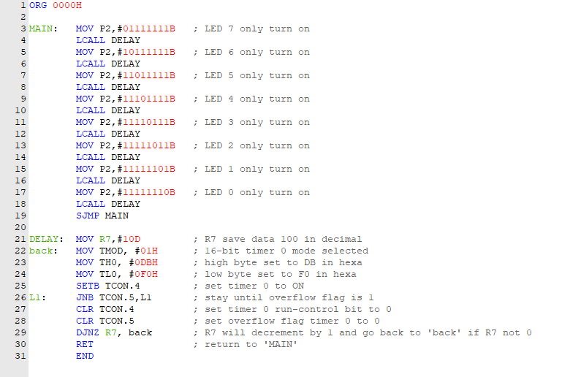

1. LED is control by port 2 from LED 0 to LED 7.
2. Port 2 is set 01111111B for LED to ON since the LED is active-LOW so that the LED 7 will ON while other will OFF
3. DELAY is called so it will jump to DELAY to be executed for next instruction
4. R7 data is set to 10 in decimal
5. Timer mode will set to 01 in hexa to select 16-bit timer 0
6. For crystal oscillator, there need to make timer count up to 10 000 since 1 machine cycles is 1µs. So, 65 536 (full timer count for crystal oscillator) must minus 10 000, 65 536 – 10 000 = 55 536 = DBF0H
7. TH0 is for high byte set so DB will be set while TH1 is for low byte set so F0 will be set
8. TCON.4 is for Timer 0 run-control bit so it will be set 1 to timer start counting
9. The instruction for timer count will keep remain until overflow flag is 1. In other words, Timer 0 finish counting.
10. TCON.4 and TCON.5 will set back to 0 to be ready to execute next instruction
11. R7 will decrement by 1 so, R7 data now is 9 and instruction will execute ‘back’ until R7 decrease until 0.
12. After R7 become 0 the instruction will execute to the first instruction which is ‘MAIN’. This will give LED to on ON for 10 x 10ms = 0.1s
13. Then, the same cycle will be execute but for port 2 10111111B. So, the LED 6 will ON while others LED will OFF for another 0.1s
14. The cycle will be same for next LED until it seems like a running light from left to right
15. Lastly, instruction will execute short jump (SJMP) to ‘MAIN’ after full complete cycle of running light and it will execute instruction repeatedly.

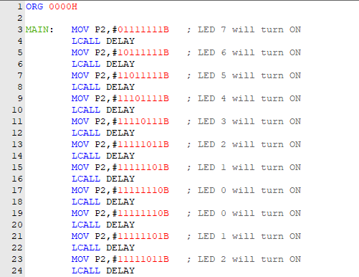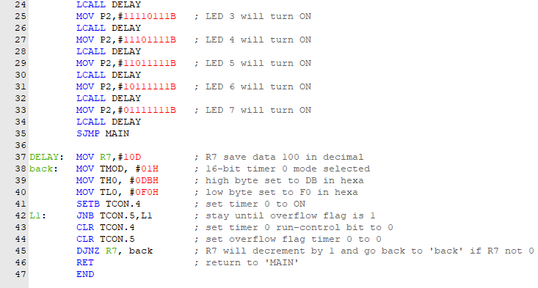

1. LED is control by port 2 from LED 0 to LED 7.
2. Port 2 is set 01111111B for LED to on since the LED is active-LOW so that LED 7 will ON while others LED will OFF
3. DELAY is called so it will jump to DELAY to be executed for next instruction
4. R7 data is set to 10 in decimal
5. Timer mode will set to 01 in hexa to select 16-bit timer 0
6. For crystal oscillator, there need to make timer count up to 10 000 since 1 machine cycles is 1µs. So, 65 536 (full timer count for crystal oscillator) must minus 10 000, 65 536 – 10 000 = 55 536 = DBF0H
7. TH0 is for high byte set so DB will be set while TH1 is for low byte set so F0 will be set
8. TCON.4 is for Timer 0 run-control bit so it will be set 1 to timer start counting
9. The instruction for timer count will keep remain until overflow flag is 1. In other words, Timer 0 finish counting.
10. TCON.4 and TCON.5 will set back to 0 to be ready to execute next instruction
11. R7 will decrement by 1 so, R7 data now is 99 and instruction will execute ‘back’ until R7 decrease until 0.
12. After R7 become 0 the instruction will execute to the first instruction which is ‘MAIN’. This will give LED to on ON for 10 x 10ms = 0.1s
13. Then, the same cycle will be execute but for port 2 10111111B. So, the LED 6 will ON while others LED will OFF for next 0.1s
14. The cycle will be same for next LED until it seems like a running light from left to right and return back from right to left
15. Lastly, instruction will execute short jump (SJMP) to ‘MAIN’ after full complete cycle of knight rider pattern and it will execute instruction repeatedly.